Test for the pupils of the 4th form
Exercise 1. Write the verb in the past tense.
make swim catch hear sing tell win
- At swimming club John ________ very slowly.
- They ____________ loud music in the street.
- At the concert the children ____________ a very funny song.
- Bob and his father ____________ a very big fish in the river.
- Sam ____________ the race and got the first prize.
- Mum _______________ a cake.
- The teacher _____________ a story.
Exercise 2. Complete the sentences with HAVE or HAS.
- You __________ helped your mother.
- I __________ taken a picture.
- My mother ________ made a pudding.
- The king ______ lost his crown.
- Somebody ________ broken the window.
- The friends ________ eaten all the cakes.
- The children _________ washed their hands.
Exercise 3. Complete the sentences. Choose the right word.
- I am going to the supermarket. Do you want …………. (something/anything)?
- What is that noise? There is …………….. (something/nothing) under the bed.
- I am really hungry but there is ……………(nothing/everything) on the table.
- I can see …………. (something/anything) in the tree. Look! It’s moving.
- The children were very quiet. They did not say ………… (everything/anything).
- The children were quiet. ……………. (Everybody/Nobody) spoke.
- The toys were fantastic. Bill wanted to buy ………. (everything/nothing) in the shop.
- ………….. (How much/How many) cows are there on the farm?
- ………….. (How much/How many) people live in the desert?
- There is not ………. (much/many) water in the desert.
- My sister has got …………… (much/lots of) friends.
- There are ……… (a few/a little) oranges on the tree.
- We can spend …………(a few/a little) time in the museum.
- …………….. (How much/How many) cakes did they eat? - They ate …………….. (a few/a little).

Exercise 4. Look at the picture and answer the questions.
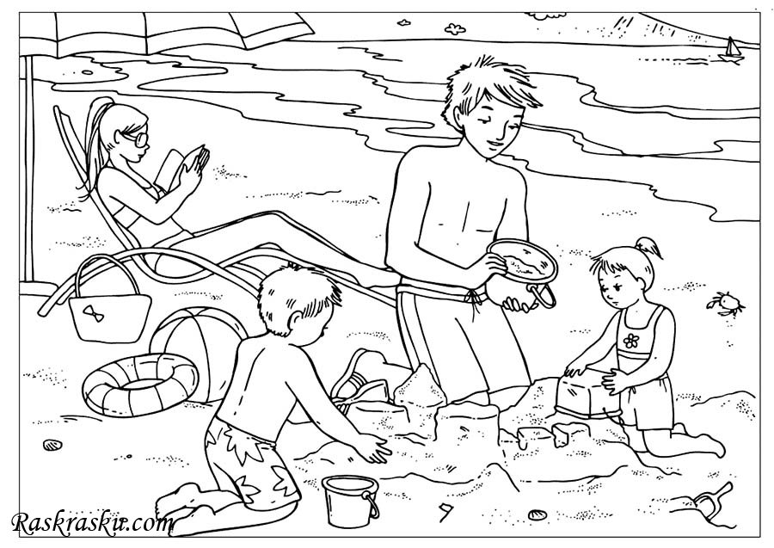

- Was it a hot day or a cold day yesterday?
____________________________________________________________
- Where were the children playing?
____________________________________________________________
- What was Mum doing?
____________________________________________________________
- Where was the boat sailing?
__________________________________________________________

Exercise 5. Read the text and choose the right sentence.

Don't Give Sweets to Bonny!
New word: sign [sain] —плакат
cage - клетка
Ann and Ben liked to watch Bonny, the monkey in the Zoo. She was very funny and the children gave her many sweets. One day Bonny was ill. Ann and Ben went to the doctor... "Can you help Bonny?"
"Open your mouth," said the doctor to Bonny. "Oh, I see. You mustn't eat sweets. They are not good for your teeth."
"We didn't know that," said Ann.
"Every day children give sweets to Bonny. What can we do?" said Ben.
"Make a sign 'Don't give sweets to Bonny!'" said the doctor.
Ann and Ben made a sign and put it on Bonny's cage.
Now children can see the sign and they don't give sweets to her. But Bonny is not happy. She runs and asks for sweets. She is little...

Choose the right sentence:
1. a) Ann and Ben were monkeys.
b) Ann and Ben were children.
c) Ann and Ben didn't like monkeys.
2. a) Bonny was a little monkey.
b) Bonny didn't like sweets.
c) Bonny liked to give sweets to children.
3. a) One day Bonny was hungry.
b) One day Bonny was ill.
c) One day Bonny was thirsty.
4. a) The doctor couldn't help Bonny.
b) The sweets were not good for Bonny. .
c) Bonny had nice white teeth.
5. a) The doctor didn't know that the sweets were not good for monkeys.
b) Ann and Ben were happy that Bonny was ill.
c) Ann and Ben didn't know that the sweets were not good for Bonny.
6. a) The doctor made a sign 'Don't give sweets to Bonny!'
b) Ann and Ben didn't make a sign.
c) Ann and Ben made a sign 'Don't give sweets to Bonny!'
7. a) Bonny is happy to eat no sweets.
b) Bonny wants to eat sweets.
c) Bonny doesn't want to eat sweets.

